EX:NO:3 Write a Servlet program that prints “Hello World!” when accessed through a browser.

AIM:
To write a servlet program that prints “Hello World!” when accessed through a browser.
ALGORITHM:
1.Start.
2.Create a JSP page and set the page language as Java.
3.Define the content type as text/html with UTF-8 encoding.
4.Create the basic HTML structure (<html>, <head>, <body>).
5.Set the page title as "Hello" inside the <title> tag.
6.In the <body> section, display the heading "Hello World!" using the <h1> tag.
7.End the HTML page.
8.Stop.
CODE:
<%@ page language="java" contentType="text/html; charset=UTF-8"
pageEncoding="UTF-8"%>
<!DOCTYPE html>
<html>
<head>
<meta charset="UTF-8">
<title>Hello</title>
</head>
<body>
<h1>Hello World!</h1>
</body>
</html>

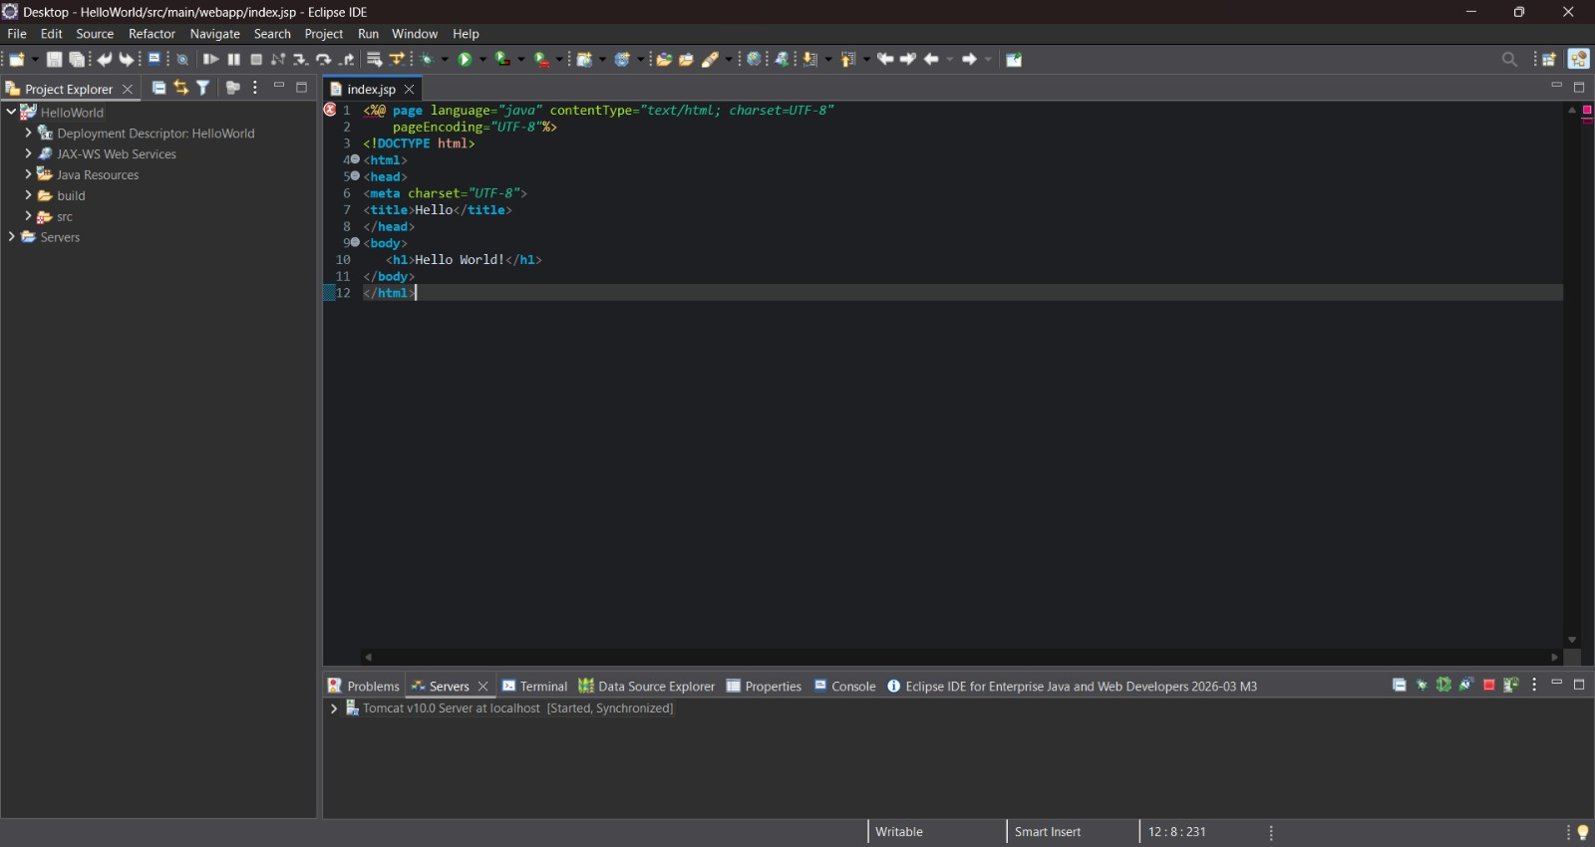

OUTPUT:
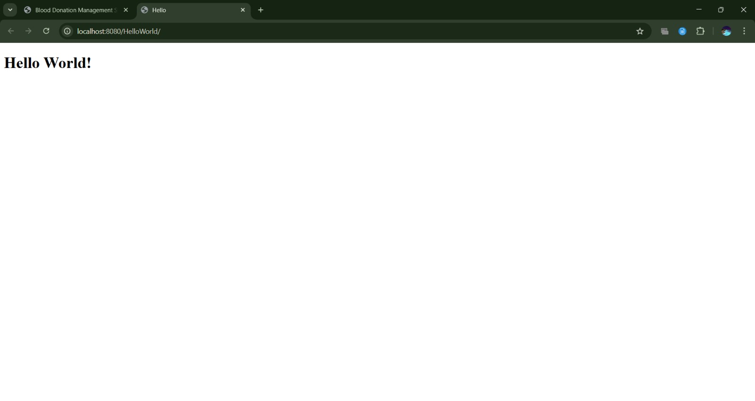

RESULT:
Thus the servlet program that prints “Hello World!” when accessed through a browser is executed successfully.

